1. **Mr. Ujjwal’s Residence:**

The interiors feature a mix of warm, natural materials and bold, dynamic accents. Modular furniture, biophilic design elements, and varied work zones create an inspiring and adaptable environment for individuals and teams.The home boasts a gourmet kitchen with state-of-the-art appliances, a tranquil master suite with a private balcony, and a landscaped backyard with a pool and fire pit for entertaining. Sustainability was a cornerstone of the design, with solar panels, rainwater harvesting systems, and energy-efficient appliances integrated seamlessly. The layout optimizes space for both private retreats and communal gatherings.

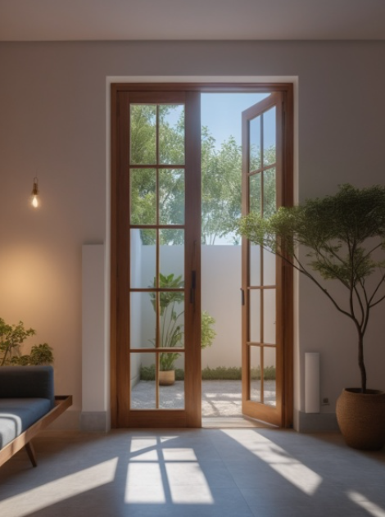

1. **Sirigere Mane:**

Located in the bustling heart of Bangalore, this residential apartment project redefines modern urban living with a focus on elegance, functionality, and sustainability. Designed to cater to professionals and families alike, the apartments offer a harmonious blend of style and practicality. The building’s contemporary design features a sleek façade of glass and concrete, complemented by green terraces. The architecture prioritizes natural light and ventilation, with strategically positioned windows and open-plan layouts that foster a sense of spaciousness. Each apartment includes smart home integration, spacious balconies with panoramic city views, and high-end appliances. The building boasts a range of shared amenities, including a state-of-the-art gym, a rooftop pool, and a landscaped communal courtyard. This residential apartment project offers more than a place to live—it provides a sanctuary where residents can thrive in comfort and style, with every detail thoughtfully designed to elevate everyday life.

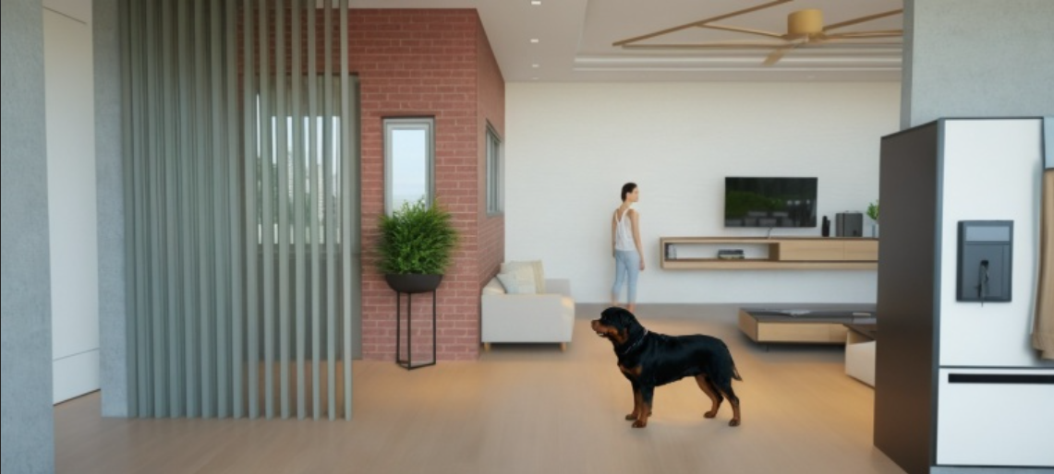

1. **Mr. Prajwal’s Residence:**

This luxury residential project redefines opulence, blending sophisticated design with unparalleled comfort. Nestled in Bangalore, the property showcases a harmonious balance of contemporary architecture and timeless elegance, tailored for discerning homeowners seeking a sanctuary of refinement and exclusivity. The interiors are a symphony of luxury and functionality, crafted with exquisite attention to detail. A neutral palette accented by rich textures and materials—such as marble, velvet, and polished wood—adds depth and sophistication. Custom furnishings, statement lighting, and curated art pieces enhance the sense of exclusivity. Every space is designed to evoke comfort and style, from the grand living room to the serene bedrooms.

1. **Mr. Shivakumar's Residence**

This luxury residential project redefines opulence, blending sophisticated design with unparalleled comfort. Nestled in Bangalore, the property showcases a harmonious balance of contemporary architecture and timeless elegance, tailored for discerning homeowners seeking a sanctuary of refinement and exclusivity. The interiors are a symphony of luxury and functionality, crafted with exquisite attention to detail. A neutral palette accented by rich textures and materials—such as marble, velvet, and polished wood—adds depth and sophistication. Custom furnishings, statement lighting, and curated art pieces enhance the sense of exclusivity. Every space is designed to evoke comfort and style, from the grand living room to the serene bedrooms.

1. **Mr. Kumar’s Residence:**

This residential project in Bangalore embodies modern elegance combined with functional design. The goal was to create a serene and inviting living space that seamlessly integrates with its natural surroundings while prioritizing comfort and sustainability. The architecture emphasizes clean lines and open spaces, featuring a minimalist façade of natural stone and glass. Large windows invite ample natural light, creating a strong indoor-outdoor connection. The result is a home that not only meets the practical needs of modern living but also serves as a sanctuary where the family can create lasting memories.

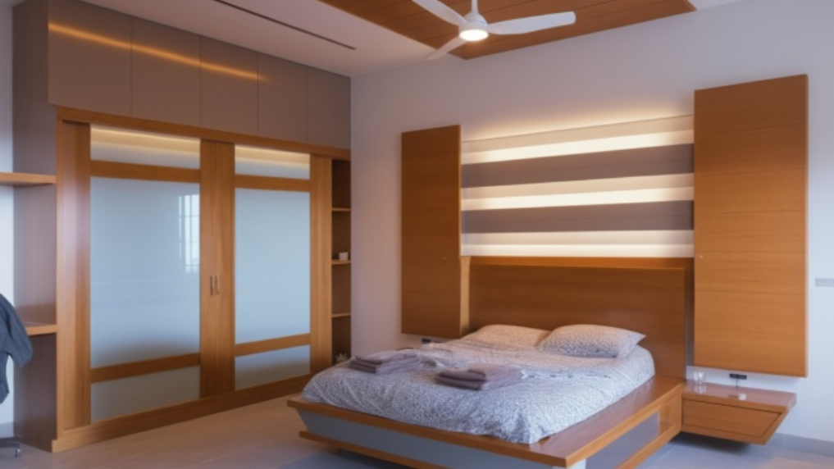

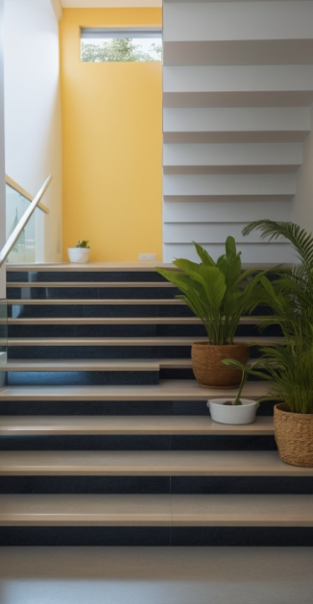

1. **Co-Working space:**

Located in the heart of Bangalore, this coworking space is designed to foster creativity, collaboration, and productivity for professionals and businesses alike. The design embraces flexibility and innovation, catering to the dynamic needs of today's workforce. The interiors feature a mix of warm, natural materials and bold, dynamic accents. Modular furniture, biophilic design elements, and varied work zones create an inspiring and adaptable environment for individuals and teams. The layout includes dedicated private offices, shared desks, breakout zones, and soundproof meeting pods. A central atrium doubles as a communal lounge, encouraging networking and informal interactions. This coworking space is more than just a workplace; it is a dynamic environment where ideas thrive, connections flourish, and work-life balance is redefined.